ULTITECH ERP
AI Agent Automation Blueprint
Visual product concept, workflow diagrams, agent interface, pop-ups and shortcuts
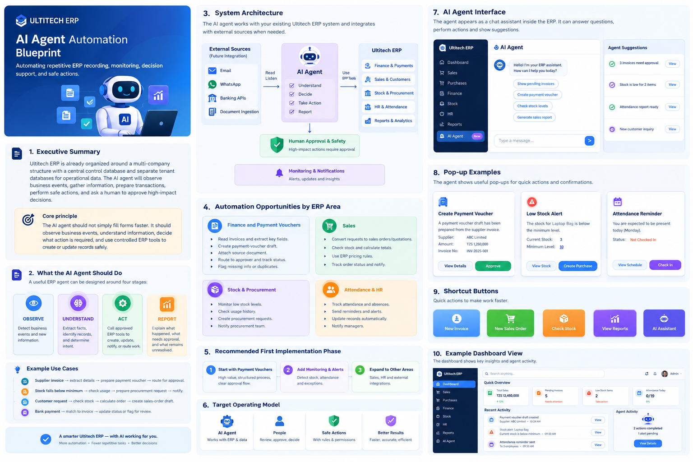
Visual concept board generated for this blueprint
Purpose
Turn the existing ERP into an event-driven operating model where the AI agent observes business events, understands information, prepares or executes controlled actions, and keeps people in control of high-impact decisions.

Source basis: provided Ultitech ERP AI Agent Automation Blueprint

Contents
A visual-first implementation and UX blueprint
1. Executive Summary
2. What the AI Agent Should Do
3. Automation Opportunities by ERP Area
4. External Information Ingestion
5. ERP Monitoring and Proactive Work
6. Administrative Automation
7. AI-Generated Reports and Insights
8. Error and Anomaly Detection
9. Human Approval and Safety Model
10. Recommended Ultitech Agent Architecture
11. Agent Interface, Pop-ups and Shortcuts
12. Recommended First Implementation Phase
13. Target Operating Model
14. Source and Scope Notes
Scope note
The supplied blueprint documents the current ERP structure. Email, WhatsApp, banking APIs and document-ingestion connectors are proposed future integrations rather than documented existing functions.

1. Executive Summary
Ultitech ERP is organized around a multi-company structure with a central control database and separate tenant databases for operational data. The supplied blueprint identifies PHP 8.x, MySQL/MariaDB, Apache, company-specific routing, centralized login indexing, payment vouchers, sales, stock, procurement-related data, meetings and notifications as the current foundation.
The strongest opportunity is to move repetitive work away from manual recording and toward event-driven automation: the agent watches for business events, gathers information from approved sources, prepares transactions, performs safe actions, and asks a human to approve high-impact financial or administrative decisions.
Core principle
The AI agent should not simply fill forms faster. It should observe business events, understand information, decide what action is required, and use controlled ERP tools to create or update records safely.

2. What the AI Agent Should Do
The operating model is organized around four stages: observe, understand, act and report. These stages should be visible in both the system architecture and the user experience.
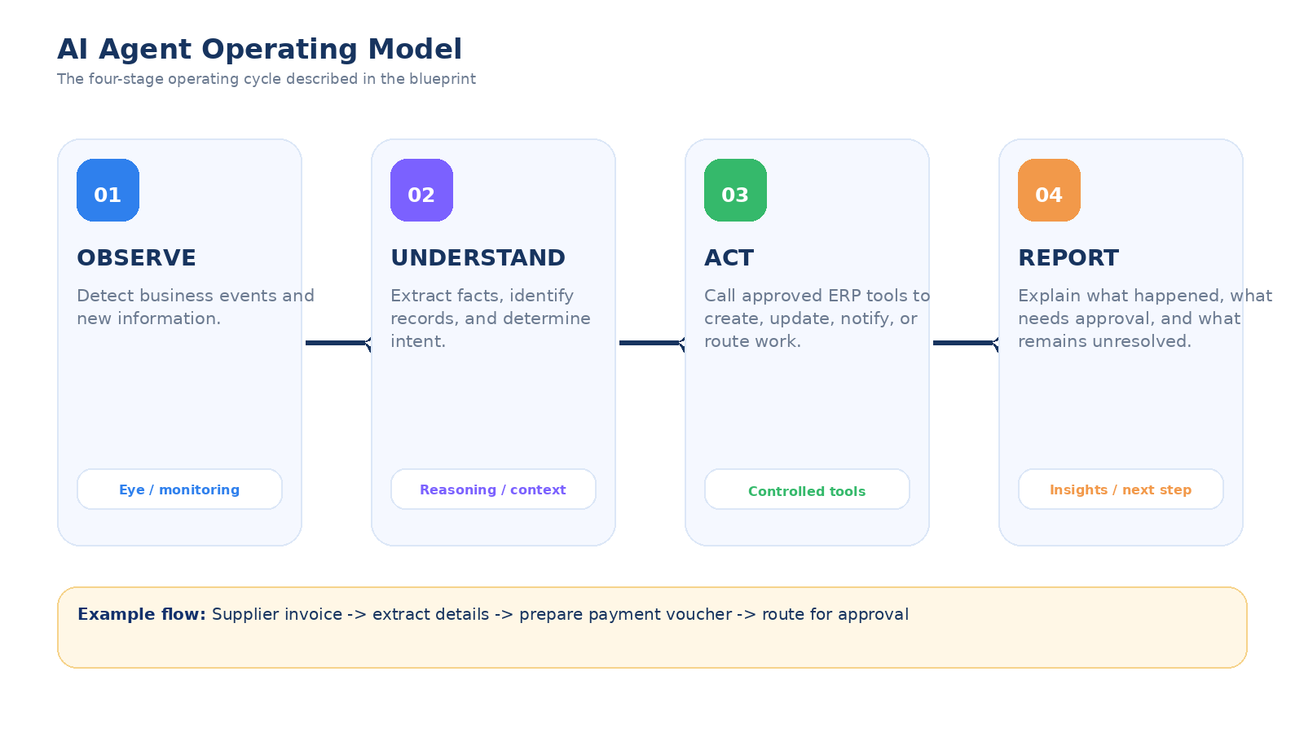
Operating model: observe -> understand -> act -> report

Example Operating Model Events
Business event | Example agent response
Supplier invoice | Extract supplier, invoice number, items, amount, VAT and due date; prepare a payment voucher draft; route for approval.
Low stock | Detect shortage; check usage history; prepare procurement request; notify procurement.
Customer request | Identify customer and products; check stock; calculate order; create sales-order draft or initiate workflow.
Incoming payment | Match to outstanding invoice; update status or flag for review when no reliable match exists.

3. Automation Opportunities by ERP Area
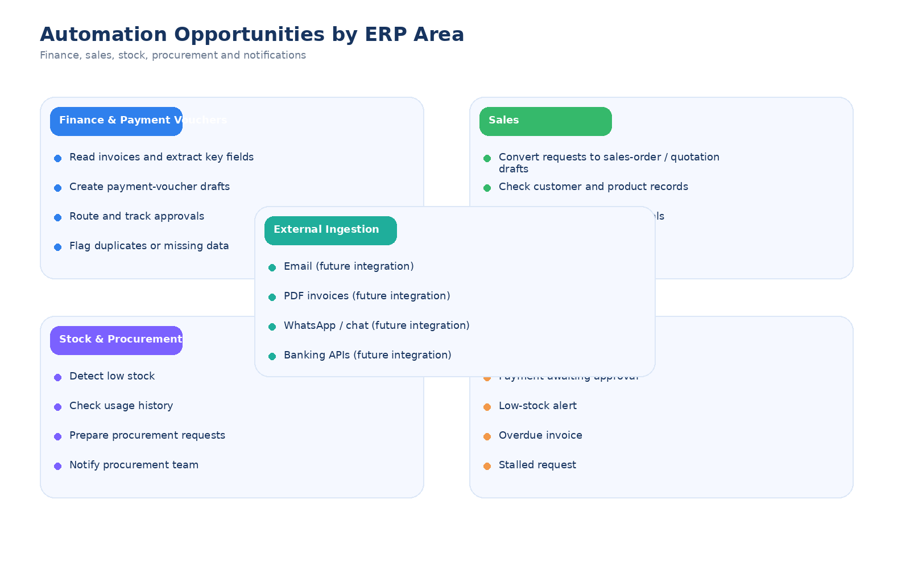
Automation map derived from the supplied blueprint
Finance and payment vouchers are a strong first automation target because the process is structured, repetitive and approval-oriented.
Sales automation can turn customer requests into sales-order or quotation drafts, search existing customer and product records, check stock, calculate totals using ERP pricing rules and track order status.
Inventory and procurement automation can detect low or critical stock, identify fast- and slow-moving items, monitor unusual stock changes and prepare procurement drafts for approval.
The existing control database includes notifications, allowing the agent to generate event-driven alerts instead of relying on employees to write notifications manually.

4. External Information Ingestion
The blueprint proposes explicit ingestion connectors so business information can enter the agent workflow where it already arrives. The agent should validate extracted data against ERP records before creating transactions.
Source | Possible agent action | Status
Email | Read approved messages and attachments; extract structured information; prepare ERP records. | Future integration
PDF invoices | Extract invoice number, supplier, items, quantities, VAT, total and due date. | Future integration
WhatsApp / customer chat | Read customer requests and initiate quotation or order workflows. | Future integration
Bank statements / banking API | Match incoming payments to receivables and flag unmatched transactions. | Future integration
Excel / CSV | Read approved files and turn rows into validated drafts or imports. | Extension; specific integration not documented

Design rule
External sources should feed the agent through explicit ingestion connectors. Validate extracted data against ERP records before creating transactions.

5. ERP Monitoring and Proactive Work
The agent can act as a continuous business monitor. Instead of waiting for users to inspect pages and search for pending work, it evaluates defined conditions and surfaces exceptions automatically.
- Unpaid and overdue customer invoices
- Outstanding supplier payables
- Payment vouchers awaiting approval
- Low or critical stock
- Purchase requests that have stalled
- Unexpected stock changes or mismatches
- Transactions that look duplicated or incomplete
- Workflows that remain in one status longer than a configured threshold
Example daily briefing
12 items require attention: 5 payment vouchers awaiting approval; 3 overdue customer invoices; 2 low-stock products; 1 procurement request stalled for 3 days; 1 possible duplicate invoice.

Suggested shortcuts: Review approvals | Review receivables | Review stock | Review exceptions

6. Administrative Automation
A controlled agent workflow could accept a structured instruction such as: "Create an account for John Peter as Procurement Officer at Roadmaster." It should validate the company, create the appropriate user record, synchronize the login index as required, assign supported roles or permissions, and send a notification while remaining within the same validation and authorization rules as the normal ERP UI.
For meetings and follow-up, the blueprint notes that meetings are already documented in the control database. An agent can extend this area by creating meetings, sending reminders, capturing action items from approved notes and creating follow-up tasks where supported.
7. AI-Generated Reports and Insights
Frequency | Typical content | Value
Daily | Sales, payments, expenses, stock alerts and pending approvals. | Fast operational awareness.
Weekly | Sales movement, cash activity, receivables, payables, procurement and stock trends. | Trend monitoring.
Monthly | Revenue, expenses, outstanding balances, stock movement, procurement activity and workflow exceptions. | Management review.
On demand | Natural-language answers to business questions using ERP data and authorized tools. | Direct access to information.

Example insight
Receivables increased mainly because four customer invoices became overdue this week. Review the overdue accounts and follow-up actions.

8. Error and Anomaly Detection
A useful agent does not only create records. It checks whether business records make sense together and highlights potential errors before they propagate.
Pattern | Agent response
Possible duplicate invoice | Flag the duplicate and present matching invoice numbers, suppliers, dates or amounts for review.
Stock discrepancy | Compare relevant stock movements and linked sales or procurement records; request investigation.
Unusual supplier price | Compare the current price with approved historical records and flag the change.
Missing transaction data | Identify required fields and ask for or retrieve missing information from an approved source.
Unexpected workflow state | Notify the responsible user and provide the underlying records that caused the alert.

9. Human Approval and Safety Model
Not every agent action should be fully automatic. The blueprint separates low-risk automation from actions that change important financial, operational or permission data.
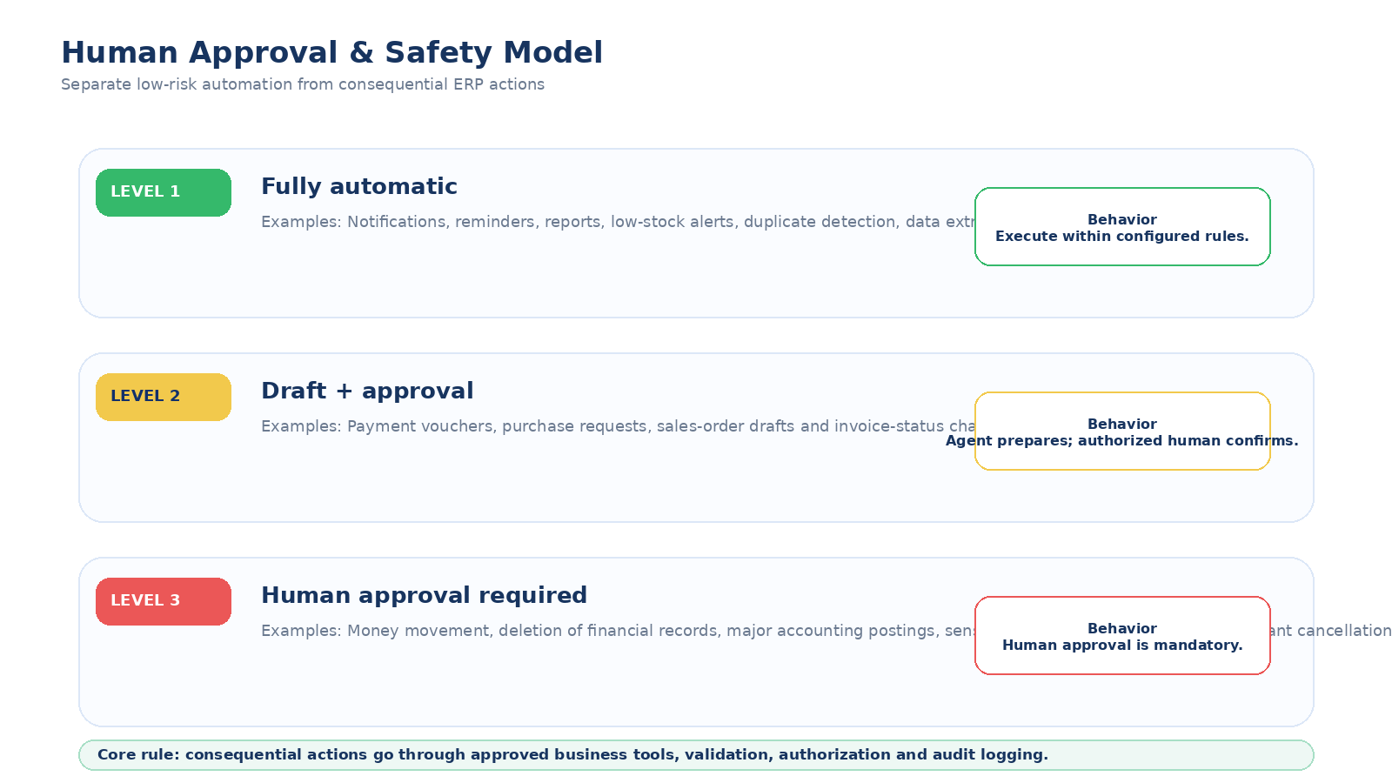
Three-level safety model
Core safety rule: the agent should never receive unrestricted authority to write arbitrary SQL against tenant databases. Consequential actions should go through approved business tools, validation, authorization and audit logging.

10. Recommended Ultitech Agent Architecture
The recommended design is an AI agent connected to a controlled tool layer. The agent reasons about what needs to happen; the tool layer enforces application rules.
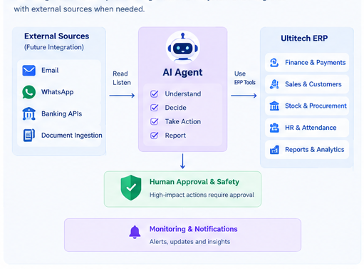
Illustrative architecture: external sources -> agent -> ERP tools -> control and tenant databases

Illustrative Agent Tool Set
Type | Example tool | Purpose
Read | get_stock() | Read current stock using authorized tenant context.
Read | search_customer() | Find a customer from ERP records.
Read | get_invoice() | Retrieve invoice details and status.
Read | get_pending_approvals() | Find work awaiting authorized action.
Action | create_payment_voucher() | Create a validated payment-voucher draft.
Action | create_sales_order() | Create a sales-order draft using ERP rules.
Action | create_purchase_request() | Create procurement work from approved triggers.
Action | create_notification() | Send an ERP notification to the responsible user.
Action | generate_report() | Produce a structured report from authorized ERP data.

Tenant security
Every agent execution should carry an explicit company context and use the same authorization boundary as the logged-in user or service identity.

11. Agent Interface, Pop-ups and Shortcuts
The user-facing concept keeps the AI agent inside the ERP rather than forcing users into a separate application. The interface should answer questions, perform approved actions and show suggestions without hiding the underlying ERP workflow.
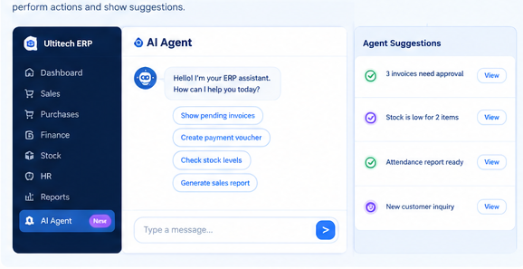
AI agent interface concept: chat workspace + suggestion panel
Recommended interaction pattern: a persistent AI Agent entry in the ERP navigation, a chat area for natural-language requests, suggested quick actions, and a side panel that surfaces items needing attention.

11A. Pop-up Concepts
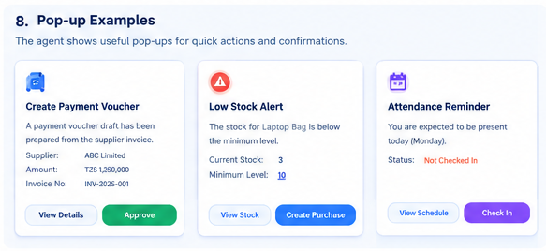
Popup concepts for payment vouchers, low stock and attendance reminders
Create Payment Voucher
Show the prepared draft details, source reference and a clear Review Details / Approve path.

Low Stock Alert
Show current stock, configured minimum, and a direct Create Purchase action.

Attendance Reminder
Explain the required action and provide a direct Check In or View Schedule action.

11B. Shortcut Concepts
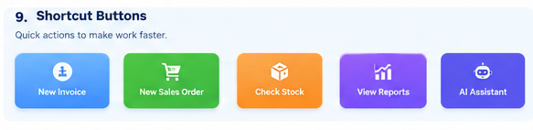
Shortcut bar concept for frequent actions
Use shortcuts for high-frequency, low-friction tasks such as New Invoice, New Sales Order, Check Stock, View Reports and AI Assistant. Keep them visually distinct but consistent with the ERP brand.

11C. Example Dashboard and Agent Activity
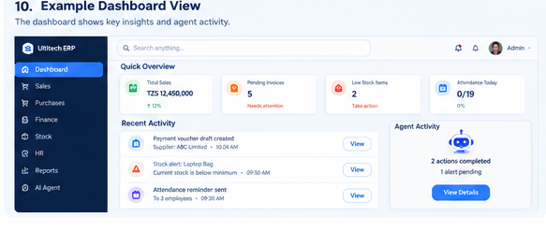
Dashboard concept showing quick overview, recent activity and agent activity
The dashboard should make the agent visible without making it the only source of truth: users should still be able to open the underlying record, review the evidence and take normal ERP actions.

12. Recommended First Implementation Phase
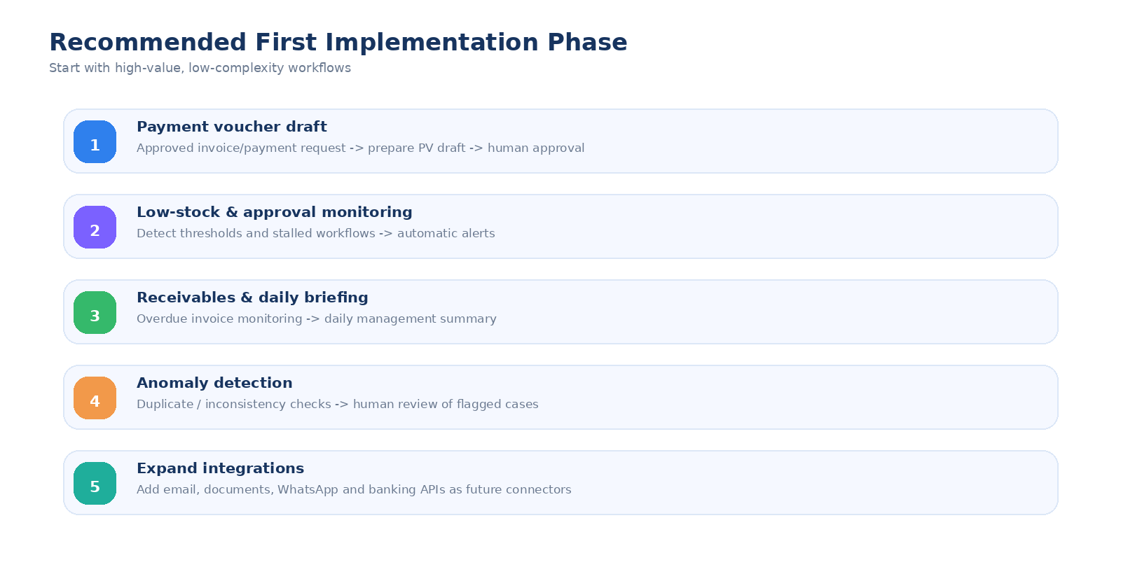
Phased implementation roadmap
The first phase should focus on high-value, low-complexity workflows that can prove the agent model without giving it unrestricted authority.
- Define the agent allowed tools and exact input/output schemas.
- Implement read-only tools first and verify tenant isolation.
- Add draft-creation tools for payment vouchers, sales orders and procurement requests.
- Add approval routing and notifications.
- Add audit logs for every agent action, including tool name, identity, tenant, timestamp, inputs, result and approval state.
- Only then introduce external ingestion such as email, documents, WhatsApp or banking integrations.

13. Target Operating Model
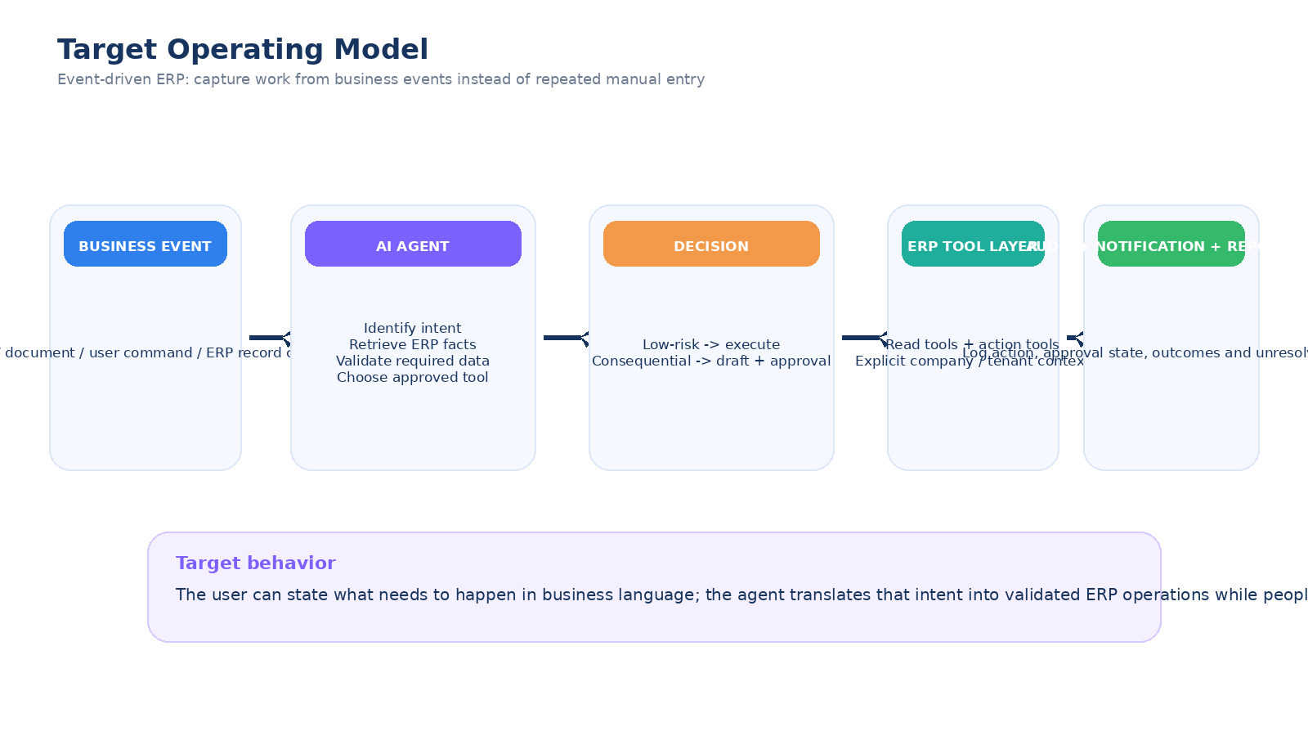
Long-term event-driven target model
The long-term model captures work from business events instead of requiring users to recreate the same information manually across forms.
Target behavior: the user states what needs to happen in business language; the agent translates that intent into validated ERP operations; low-risk actions can execute automatically; consequential actions become drafts that request approval; audit, notification and reporting close the loop.
What changes for the user
Today a user may open a form, search for data, type values, save a record and notify another person. In the target model, the user can provide the business instruction once and the agent handles retrieval, preparation, routing and notifications where permitted.

14. Source and Scope Notes
This visual blueprint is based on the provided Ultitech ERP AI Agent Automation Blueprint. The source describes a multi-company PHP ERP running on XAMPP locally and StackCP in production, with a control database for shared metadata and tenant databases for operational data. It documents company mapping, centralized login routing, payment vouchers, sales, products, stock/procurement-related data, meetings, notifications, configuration and deployment/security notes.
The source does not document dedicated AI-agent services, email ingestion, WhatsApp integration, banking APIs or document-processing pipelines. These items are presented here as proposed extensions rather than existing capabilities.
Exact tool names, database fields, permissions, approval rules, event triggers and integration mechanisms should be mapped to the actual ERP codebase before implementation.
Conclusion
The most valuable role for the Ultitech AI agent is to eliminate repetitive recording while preserving the ERP as the authoritative system of record. Start with safe monitoring and draft creation, then expand toward external data ingestion and broader workflow automation.

